* For deleting of the bucket, we should type s3 in the search bar. And click on the buckets.  
    
  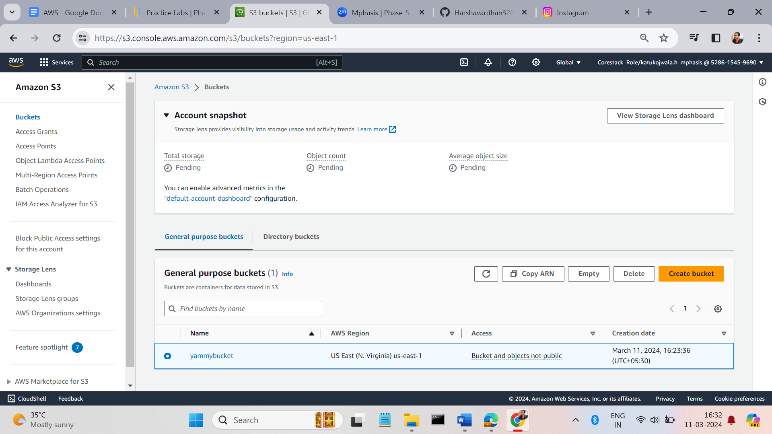
* Select the bucket which you want to delete and click the delete option. If the buckets is not empty the delete option is decibel.   
    
    
  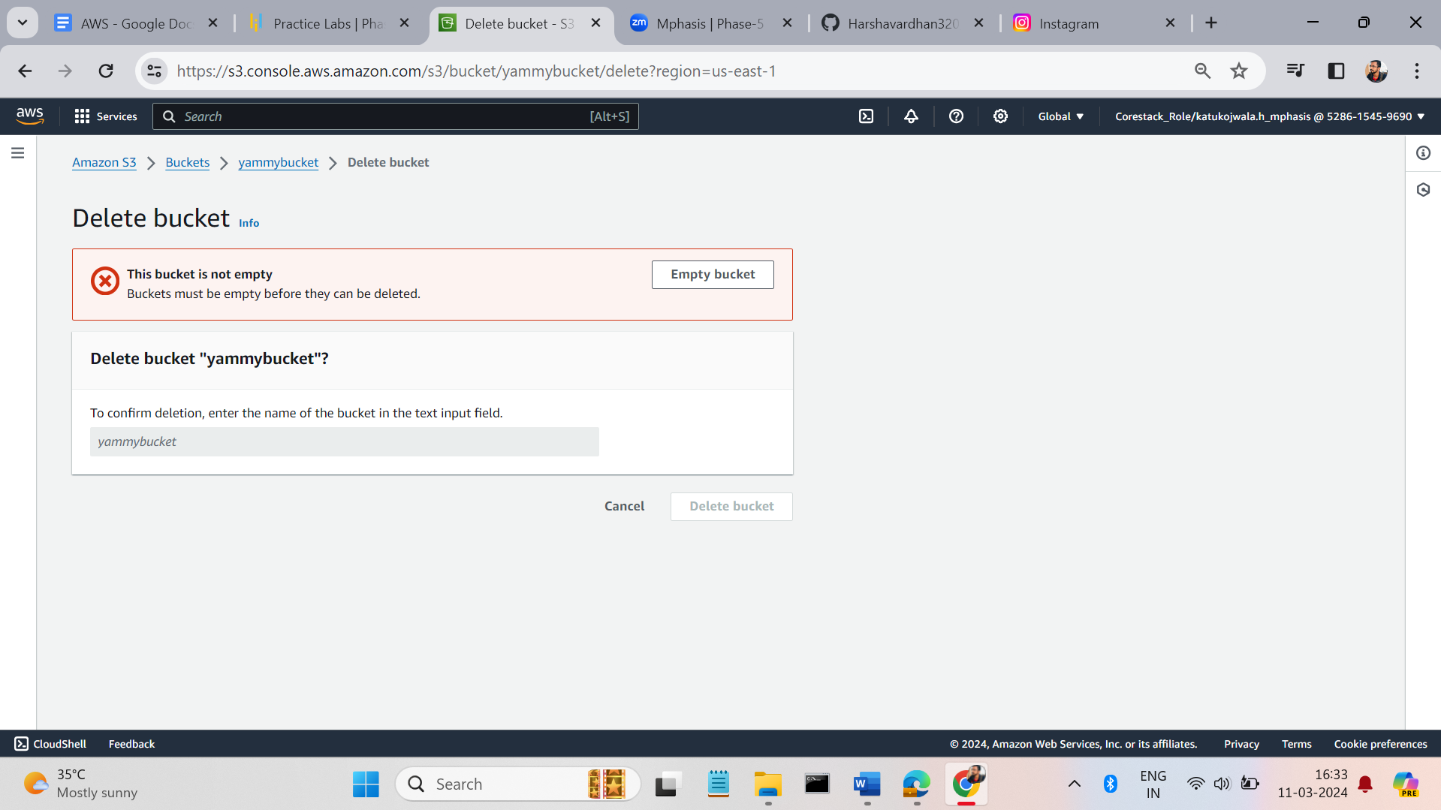  
    
    
    
    
  Empty the bucket
* 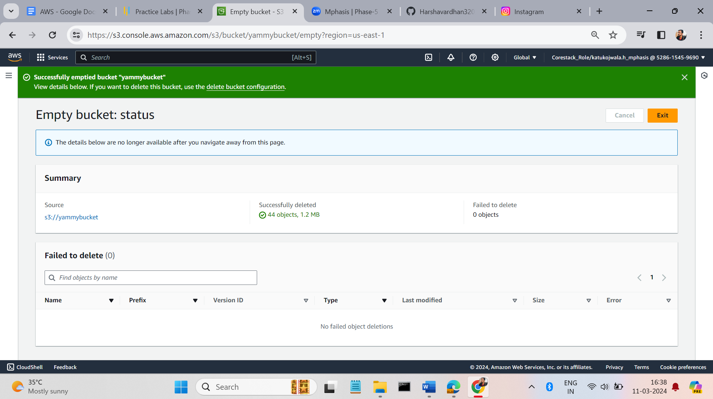
* delete the bucket now.  
    
  